Mafalda Thomas-Bouzy
aka Sistah Mafalda

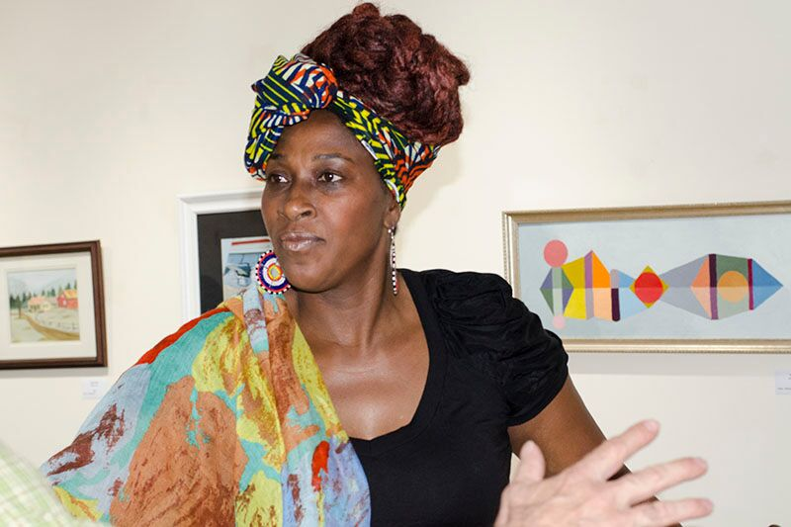

Stories of Jubilation: Mafalda Thomas-Bouzy
Dancer-Drummer
Philadelphia PA
Fellowship: 2016/2015
"I have created a village of rhythm and movement and dance and love," says master drummer Mafalda. "I started with my own children, and over the course of 20 years, created a living village of art: performing, visual, all of it; in communities far and wide, by reaching out to children, and teaching them to believe that 'I'm somebody!' Using dance to teach it. To the day I die, I'll be reaching and teaching these children and giving them a home."
An African-American single mom of three, Mafalda wanted them to be involved in cultural activities. "So we took African drum and dance classes," she says. One winter, during a major snowstorm, she couldn't get them to class. "I decided to teach it myself, and share what we had learned with other families and neighbors." Her impromptu classes snowballed and soon she was teaching the community at large. A few years later she founded the Kuumba Performers ensemble, and never looked back. "There was a need for cultural enrichment," she says, "especially in the Black and Latino neighborhoods."
Tireless and talented, Mafalda uses music and movement to stimulate compassion and care. "Drum and dance is fundamental in Africa. The movements and rhythms reveal cultural practices, such as hunting, fishing, washing clothes in the river, rites of passage, and harvesting. Work songs and social dances all reveal hidden lessons. Through participatory learning, this in-depth experience can develop students' memory and focus. It empowers them to embrace cultural diversity. Plus it promotes good health in mind, body, and spirit."
Teaching philosophy:
"Play, play, play, having a good time! Specifically, the techniques I use are:
- Call and Response: repetition of information, back and forth
- Affirmation and Individuality: encouraging students to be themselves and interpret the movement on their own
- Positive Encouragement: singling out students to exemplify a movement
- Collective Participation: every person in the classroom is a teacher
- Community Building: people must come together based on shared ideas, instead of looking for differences."
How do you produce a vibrant learning environment?
"Playfulness, rhythm, freedom in movement, connecting with the energy in the room, strengthening connections with our own bodies and others, drumming on buckets, djembes. I encourage kids to release their feelings, drum it, dance it, laugh and play it. Also by listening, giving them permission to laugh and have fun. And compassion, compassion, compassion. We talk about events, local and global; this opens their antennas of compassion.”
How do you encourage youth leadership?
"Confidence builds leaders. I follow a tradition of raising up children through dance. Allowing, in the heat of movement and energy, to pull students out to be that leader. I allow them to lead within the movement. Students are free in my classes to move and shout. I meet them where they are with the rhythms and dances of today, like hip hop. I tell them, 'You can groove and move without profanity and violence.'"
How have you evolved as a teacher?
"I am constantly discovering new ways to reach kids, and teach kids. I exchange culturally with other artists, learn new techniques, new dances. I travel – it's a big world out there. I bring back objects to share with the kids, and stories about the countries. I explore different techniques, work with different communities, and different languages: African, Latin."
Link:
www.mafaldatdance.info

